**Experiment1.1**

**Student Name: Praduman Kumar UID: 20BCS9446**

**Branch: CSE Section/Group: 714/A**

**Semester: 6th**

**Date of Performance: 15/02/2023**

**Subject Name: Data Mining Lab Subject Code: 20CSP-376**

1. **Aim:** Demonstration of preprocessing on .arff file using student data .arff.
2. **Steps:**

* Install RWeka package using command install.packages("RWeka").
* Import the RWeka library.
* Set the directory of the workspace using setwd().
* Create the table and use data.frame() to create data frame of the inserted data.
* To know the structure of the table we can write print(str(data_frame_name)) .
* To see the details of the table print(class(name_of_table)).
* At last create the arff file with the command

**write.arff(menu,file='menu.arff')**

**Code:**

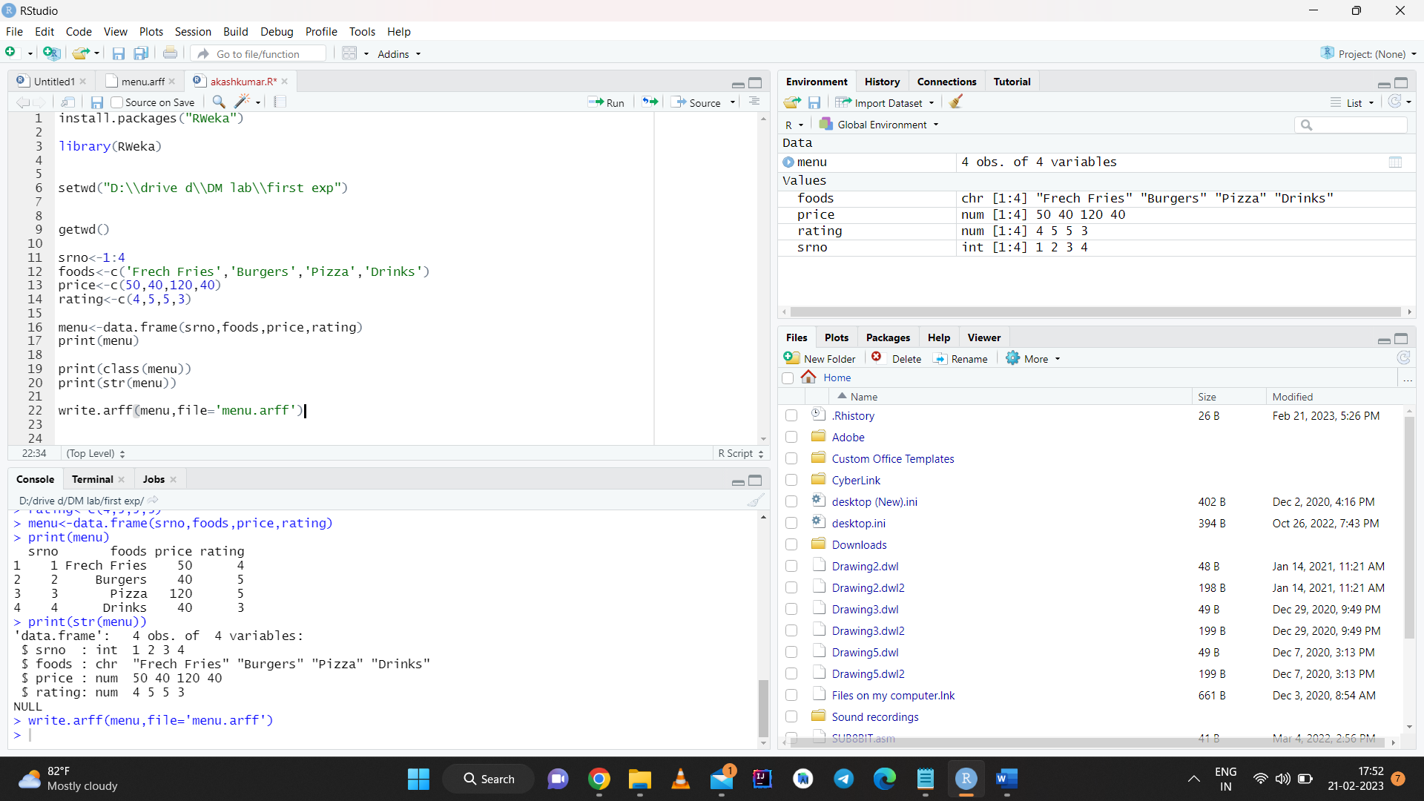

**Commands and output:**

install.packages(“RWeka”)

library(RWeka)

setwd("D:\\drive d\\DM lab\\first exp")

getwd()

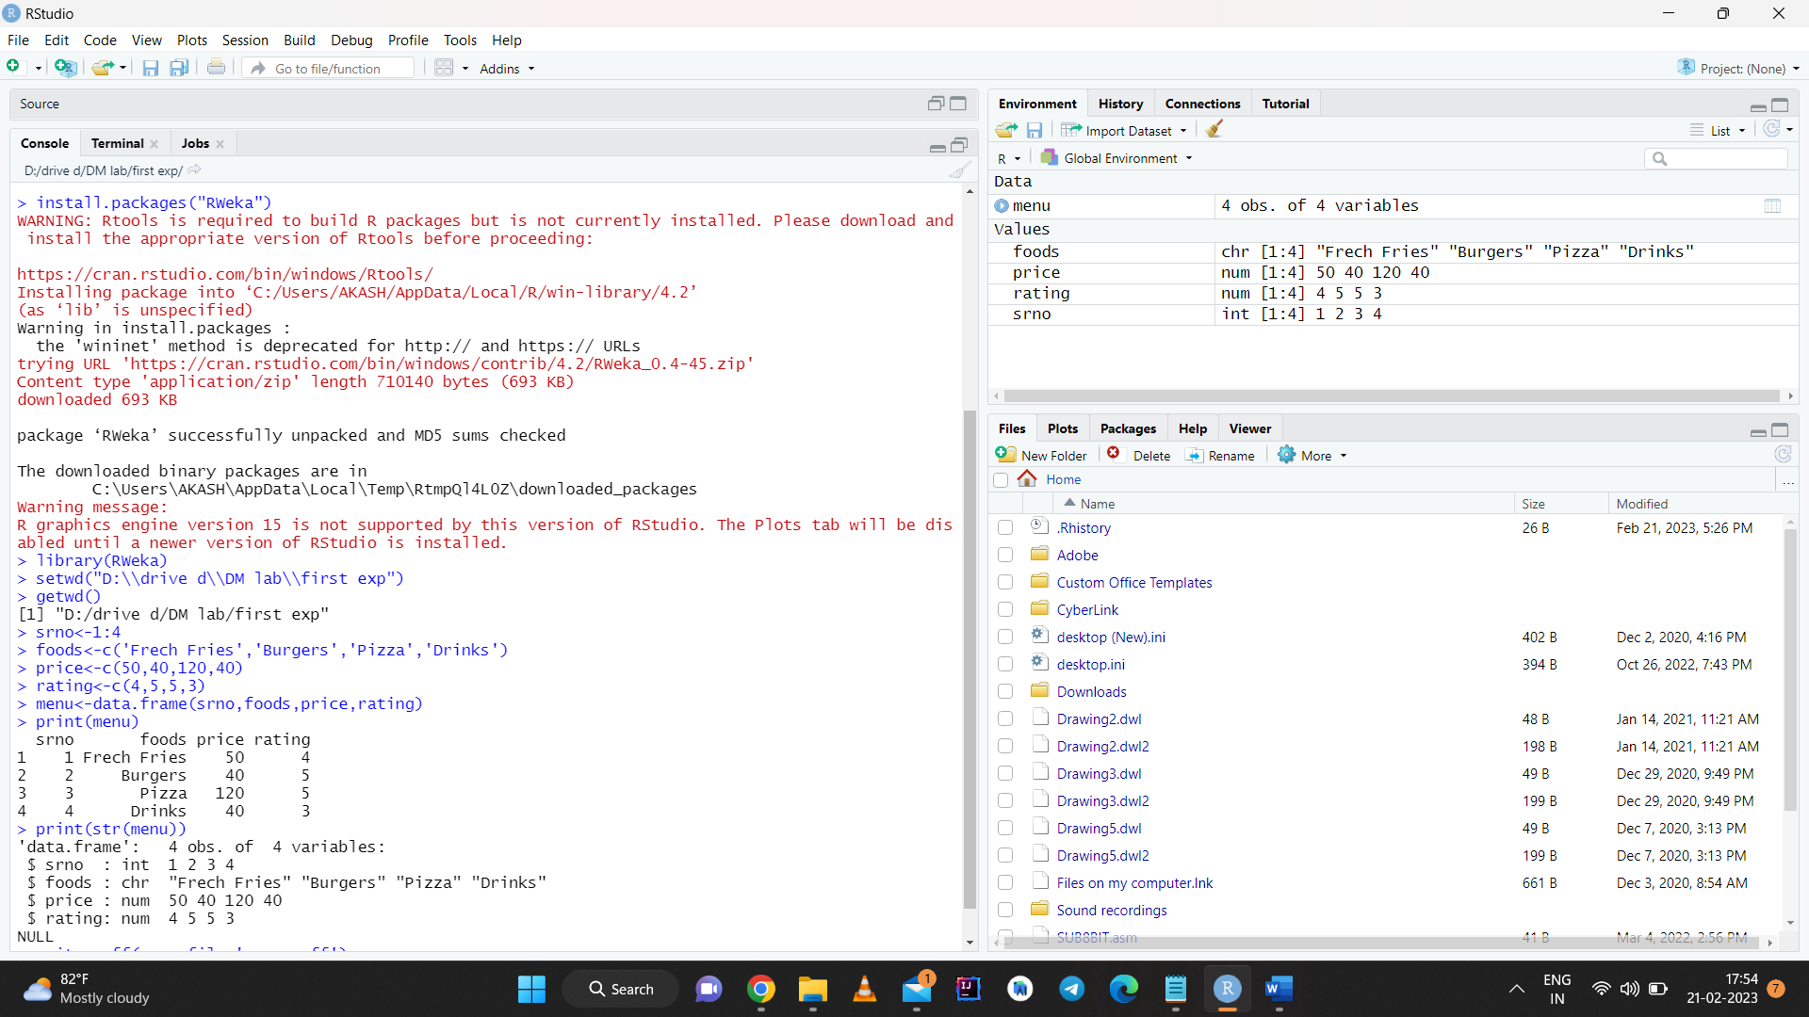

srno<-1:4

foods<-c('Frech Fries','Burgers','Pizza','Drinks')

price<-c(50,40,120,40)

rating<-c(4,5,5,3)

menu<-data.frame(srno,foods,price,rating)

print(menu)

print(class(menu))

print(str(menu))

write.arff(menu,file='menu.arff')

**.arff file**

